ERTMS/ETCS – Class 1
System Requirements Specification
Chapter 2
Basic System Description
REF : | SUBSET-026-2
ISSUE : | 2.3.0
DATE : | 24.02.2006

Company | Technical Approval | Management approval
ALCATEL

ALSTOM

ANSALDO SIGNAL

BOMBARDIER

INVENSYS RAIL

SIEMENS

Modification History
Issue Number  Date | Section Number | Modification / Description | Author
0.0.1  19 july 1999 | All | First class 1 draft using new templates and including contributions from WPs | PZ
0.1.0  26 july 1999 | System architecture figure  § 2.3.1.2 | Updating and introduction of Radio infill  Reference to future class 1 deleted | PZ
1.0.0  29 July 1999 | Document version, editorial changes, updating the architecture figure. | Finalisation in Stuttgart 990729 | HE
1.2.0  990730 | Version number | Release version | HE
1.2.1  991209 | All | Draft for 2nd release | SAB
1.3.0  9912016 | All | Review comments added | SAB
2.0.0  991222 | Minor editing | Finalisation | SAB
2.0.1 | All | Corrections after review | SAB
2.1.0 | Minor editing | UNISIG release | SAB
2.2.0 | Version number | UNISIG release | SAB
2.2.2  1.2.2002 | Version number | Final edition | Ch. Frerichs
2.3.0  24/02/06 | Version number  No change since 2.2.2 | Release version | HK

Table of Contents
2.1 Modification History 2
2.2 Table of Contents 3
2.3 Introduction 4
2.3.1 Scope and purpose 4
2.4 System structure 5
2.5 Sub-systems 6
2.5.1 Trackside subsystem 6
2.5.2 On-board sub-system 7
2.5.3 UNISIG ERTMS/ETCS reference architecture 8
2.6 Levels and transitions 10
2.6.1 Introduction 10
2.6.2 Definitions 10
2.6.3 ERTMS/ETCS Application Level 0 12
2.6.4 ERTMS/ETCS Application Level STM 14
2.6.5 ERTMS/ETCS Application Level 1 16
2.6.6 ERTMS/ETCS Application Level 2 19
2.6.7 ERTMS/ETCS Application Level 3 22
2.6.8 Level transitions 24

Introduction

Scope and purpose

The present chapter gives the basic description of the system proposed to satisfy the mandatory functional requirements of the Function Requirements Specification Version 4.3.

System structure

Due to the nature of the required functions, the ERTMS/ETCS system will have to be partly on the trackside and partly on board the trains.

This defines two sub-systems, the on-board sub-system and the trackside sub-system.

The environment of ERTMS/ETCS system is composed of:
- the train, which will then be considered in the train interface specification;
- the driver, which will then be considered via the driver interface specification;
- other onboard interfaces (see architecture drawing in 2.5.3),
- external trackside systems (interlockings, control centres, etc.), for which no interoperability requirement will be established.

Sub-systems

Trackside subsystem

Depending of the application level (see further sections), the trackside sub-system can be composed of:
- balise
- lineside electronic unit
- the radio communication network (GSM-R)
- the Radio Block Centre (RBC)
- Euroloop
- Radio infill unit

Balise

The balise is a transmission devices that can send telegrams to the on-board sub-system.

The balise is based on the existing Eurobalise specifications. These documents are included in the frame of the ERTMS/ETCS Class 1 specifications.

The balises provides the up-link, i. e. the possibility to send messages from trackside to the on-board sub-system.

The balises can provide fixed messages or, when connected to a lineside electronic unit, messages that can be changed.

The balises will be organised in groups, each balise transmitting a telegram and the combination of all telegrams defining the message sent by the balise group.

Lineside electronic unit

The lineside electronic units are electronic devices, that generate telegrams to be sent by balises, on basis of information received from external trackside systems.

Trackside radio communication network (GSM-R)

The GSM-R radio communication network is used for the bi-directional exchange of messages between on-board sub-systems and RBC or radio infill units.

The GSM Radio system is neither developed nor standardised within the frame of the ERTMS/ETCS Class 1 specifications. ERTMS/ETCS Class 1 uses the interfaces as specified in the EIRENE/MORANE specifications [UNISIG Reference documents, SUBSET-008, SUBSET-052].

RBC

The RBC is a computer-based system that elaborates messages to be sent to the train on basis of information received from external trackside systems and on basis of information exchanged with the on-board sub-systems.

The main objective of these messages is to provide movement authorities to allow the safe movement of trains on the Railway infrastructure area under the responsibility of the RBC.

The interoperability requirements for the RBC are mainly related to the data exchange between the RBC and the on-board sub-system.

Euroloop

The Euroloop subsystem operates on Level 1 lines, providing signalling information in advance as regard to the next main signal in the train running direction.

The Euroloop subsystem is composed of an on-board functionality and by one or more trackside parts.

Radio in-fill Unit

The RADIO IN-FILL subsystem operates on Level 1 lines, providing signalling information in advance as regard to the next main signal in the train running direction.

The RADIO IN-FILL subsystem is composed of an on-board functionality and by one or more trackside parts (named RADIO IN-FILL Unit).

On-board sub-system

Depending of the application level (see further sections), the on-board sub-system can be composed of:
- the ERTMS/ETCS on-board equipment;
- the on-board part of the GSM-R radio system;
- specific transmission modules for existing national train control systems.

ERTMS/ETCS on-board equipment

The ERTMS/ETCS on-board equipment is a computer-based system that supervises the movement of the train to which it belongs, on basis of information exchanged with the trackside sub-system.

The interoperability requirements for the ERTMS/ETCS on-board equipment are related to the functionality and the data exchange between the trackside sub-systems and the on-board sub-system and to the functional data exchange between the on-board sub-system and:
- the driver;
- the train;
- the specific transmission modules (STM’s).

Onboard radio communication system (GSM-R)

The GSM-R on-board radio system is used for the bi-directional exchange of messages between on-board sub-system and RBC or radio infill unit.

The GSM Radio system is neither developed nor standardised within the frame of the UNISIG requirements specifications [UNISIG Reference documents, SUBSET-008].

UNISIG ERTMS/ETCS reference architecture

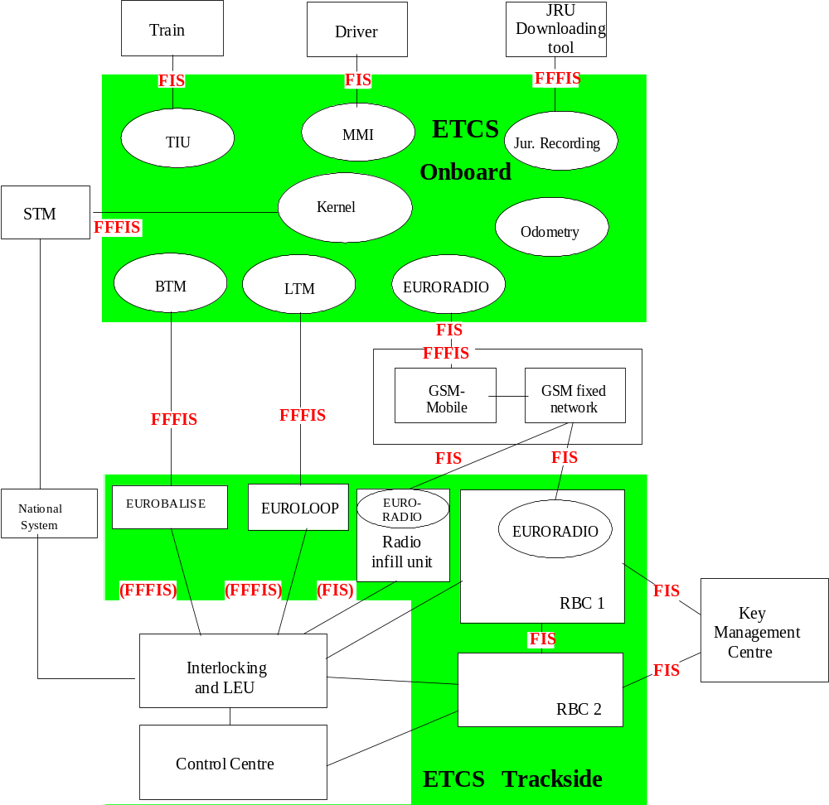
Figure 1: ERTMS/ETCS system

Note: Interfaces in brackets are not required for interoperability.

Levels and transitions

Introduction

The different ERTMS/ETCS application levels (short: levels) are a way to express the possible operating relationships between track and train. Level definitions are principally related to the trackside equipment used, to the way trackside information reaches the on-board units and to which functions are processed in the trackside and in the on-board equipment respectively.

Different levels have been defined to allow each individual railway administration to select the appropriate ERTMS/ETCS application trackside, according to their strategies, to their trackside infrastructure and to the required performance. Furthermore, the different application levels permit the interfacing of individual signalling systems and train control systems to ERTMS/ETCS.

For the purpose of a consistent specification a level 0 has been defined. This level is used for operation on non-equipped (unfitted) lines or on lines, which are in commissioning.

Definitions

A train equipped with ERTMS/ETCS on-board equipment always co-operates with the ERTMS/ETCS trackside equipment in a defined ERTMS/ETCS level.

All transitions between levels are performed according to well-specified rules.

ERTMS/ETCS can be configured to operate in one of the following application levels:
- ERTMS/ETCS Level 0 (train equipped with ERTMS/ETCS operating on a line without ERTMS/ETCS or national system or with the ERTMS/ETCS systems in commissioning)
- ERTMS/ETCS Level STM (train equipped with ERTMS/ETCS operating on a line equipped with a national system to which it interfaces by use of an STM)
- ERTMS/ETCS Application Level 1 with or without infill transmission (train equipped with ERTMS/ETCS operating on a line equipped with Eurobalises and optionally Euroloop or Radio infill)
- ERTMS/ETCS Application Level 2 (train equipped with ERTMS/ETCS operating on a line controlled by a Radio Block Centre and equipped with Eurobalises and Euroradio) with train location and train integrity proving performed by the trackside
- ERTMS/ETCS Application Level 3 (similar to level 2 but with train location and train integrity supervision based on information received from the train)

It is possible to superimpose several application levels in parallel on the same track, for example to run trains without train integrity device in level 2 and in parallel trains equipped with train integrity device in level 3. Other examples might be a station which is shared by trains arriving over level 1 and level 2 lines (junctions) or parallel operation of a national system with ERTMS/ETCS. Mixed levels are supported.

Levels 1, 2 and 3 are downwards compatible. This means that a level 3 equipped train is able to operate in level 1 and 2 and a level 2 equipped train in level 1.

Note: Operation under STM is not part of the downward compatibility chain.

It is possible to transmit information not intended for ERTMS/ETCS but for other systems over the ERTMS/ETCS transmission channels. This information is ignored by ERTMS/ETCS.

ERTMS/ETCS Application Level 0

General description

Level 0 covers operation of ETCS equipped trains on lines not equipped with ETCS or national systems or on lines which are in commissioning, e.g. where trackside ERTMS/ETCS infrastructure may exist but has to be ignored.

In Level 0 line side optical signals or other means of signalling external to ERTMS/ETCS are used to give movement authorities to the driver.

ERTMS/ETCS on-board equipment provides no supervision except of the maximum design speed of a train and maximum speed permitted in unfitted areas.

Train detection and train integrity supervision are performed by the trackside equipment of the underlying signalling system (interlocking, track circuits etc.) and are outside the scope of ERTMS/ETCS.

Level 0 uses no track-train transmission except Eurobalises to announce/command level transitions. Eurobalises therefore still have to be read. No balise data except certain special commands are interpreted.

No supervisory information is indicated on the driver MMI except the train speed. The maximum permitted speed is only displayed temporarily and on driver request. Train data has to be entered in order not to have to stop a train at a level transition to ERTMS/ETCS equipped area and to supervise maximum train speed.
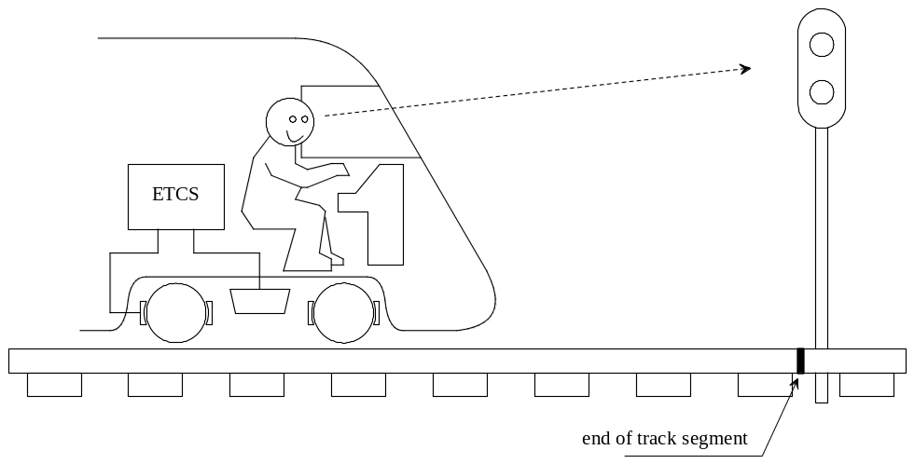
Figure 2: ERTMS/ETCS Application Level 0

Summary of characteristics of Application Level 0

Trackside equipment:
- No ERTMS/ETCS trackside equipment is used except for Eurobalises to announce level transitions and other specific commands.

Main ERTMS/ETCS trackside functions:
- None.

On-board equipment:
- Onboard equipment with Eurobalise transmission.

Main ERTMS/ETCS on-board functions:
- Supervision of maximum train speed.
- Supervision of maximum speed permitted in an unfitted area.
- Reading of Eurobalises to detect level transitions and certain special commands. All other messages are rejected.
- No cab signalling.

ERTMS/ETCS Application Level STM

General description

Level STM is used to run ERTMS/ETCS equipped trains on lines equipped with national train control and speed supervision systems.

Train control information generated trackside by the national train control system is transmitted to the train via the communication channels of the underlying national system and transformed onboard into information interpretable by ERTMS/ETCS.

Note: Lineside optical signals might be necessary or not, depending on the performance and functionality of the underlying systems.

The device which allows the ERTMS/ETCS onboard equipment to utilise the transmission system of the national system is called STM (specific transmission module).

The achievable level of supervision is similar to the one provided by the underlying national systems.

Train detection and train integrity supervision are performed by equipment external to ERTMS/ETCS.

Level STM uses no ERTMS/ETCS track-train transmission except to announce/command level transitions and specific commands related to balise transmission. Eurobalises therefore still have to be read. No data except level transition commands and certain special commands are interpreted.

The information displayed to the driver depends on the functionality of the underlying national system. The active STM is indicated to the driver as part of that information. Full train data has to be entered in order not to have to stop a train at a level transition position and to supervise maximum train speed.

Each combination of national trackside systems shall be combined externally to the ERTMS/ETCS Onboard system and shall be regarded as one STM level.

The reuse of ERTMS/ETCS Onboard functionality can be different depending on the configuration of a specific STM.

Access to ERTMS/ETCS Onboard supervision functions is supported.

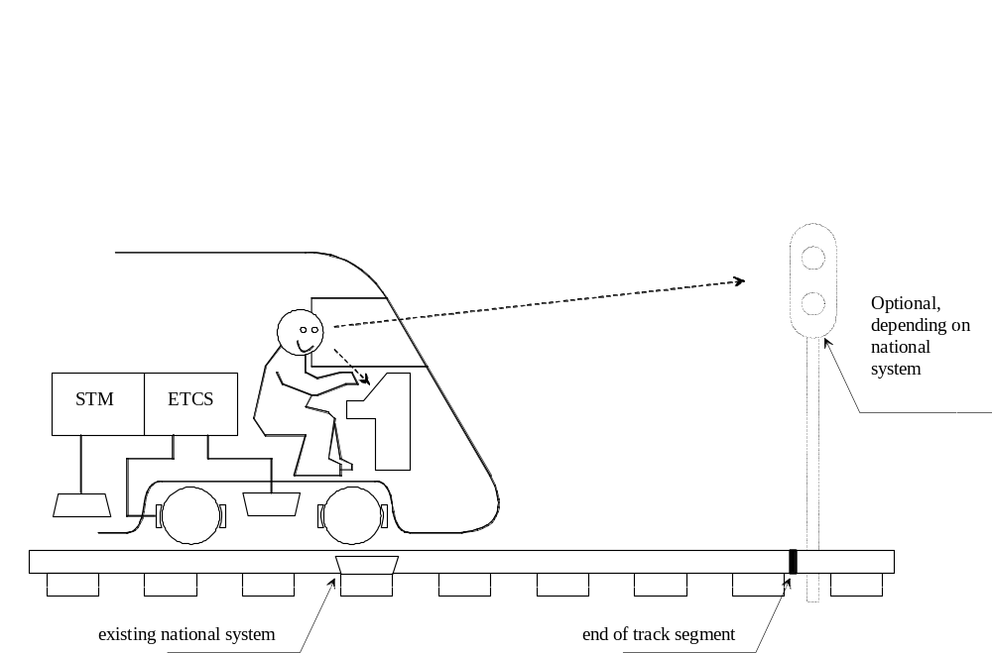

Figure 3: ERTMS/ETCS Application Level STM

Summary of characteristics of Application Level STM

Trackside equipment:
- Level STM uses the track-train transmission system from an underlying national system, which is not part of ERTMS/ETCS.
- For level transition purposes Eurobalises are used.

Main ERTMS/ETCS trackside functions:
- None.

On-board equipment:
- Onboard equipment with Eurobalise transmission.
- STM compatible with the respective national infrastructure.

Main ERTMS/ETCS on-board function:
- Depending on national system and on STM implementation.
- Reading of Eurobalises to detect level transitions and certain special commands. All other messages are rejected.
- Management of STM’s.
- Cab signalling to the driver (depending on national system).

ERTMS/ETCS Application Level 1

General description

ERTMS/ETCS Level 1 is a spot transmission based train control system to be used as an overlay on an underlying signalling system.

Movement authorities are generated trackside and are transmitted to the train via Eurobalises.

ERTMS/ETCS Level 1 provides a continuous speed supervision system, which also protects against overrun of the authority.

Train detection and train integrity supervision are performed by the trackside equipment of the underlying signalling system (interlocking, track circuits etc.) and are outside the scope of ERTMS/ETCS.

Level 1 is based on Eurobalises as spot transmission devices.

The trackside equipment does not know the train to which it sends information.

If in level 1 a lineside signal clears, an approaching train can not receive this information until it passes the Eurobalise group at that signal. The driver therefore has to observe the lineside signal to know when to proceed. The train has then to be permitted to approach the stopping location below a maximum permitted release speed.

Additional Eurobalises can be placed between distant and main signals to transmit infill information, the train will receive new information before reaching the signal.

Note: Lineside signals are required in level 1 applications, except if semi-continuous infill is provided.

Semi-continuous infill can be provided using Euroloop or radio in-fill. In this case, the on-board system will be able to show new information to the driver as soon as it is available and even at standstill.

Euroloop or radio in-fill can improve the safety of a level 1 system as they allow the operation without release speed.
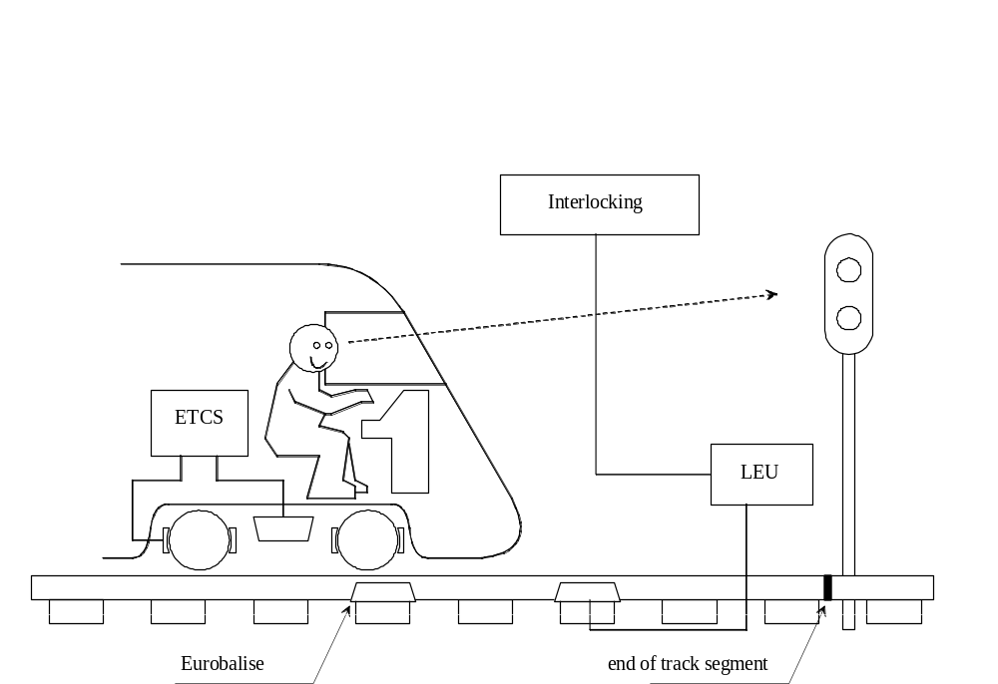

Figure 4: ERTMS/ETCS Application Level 1 without infill function
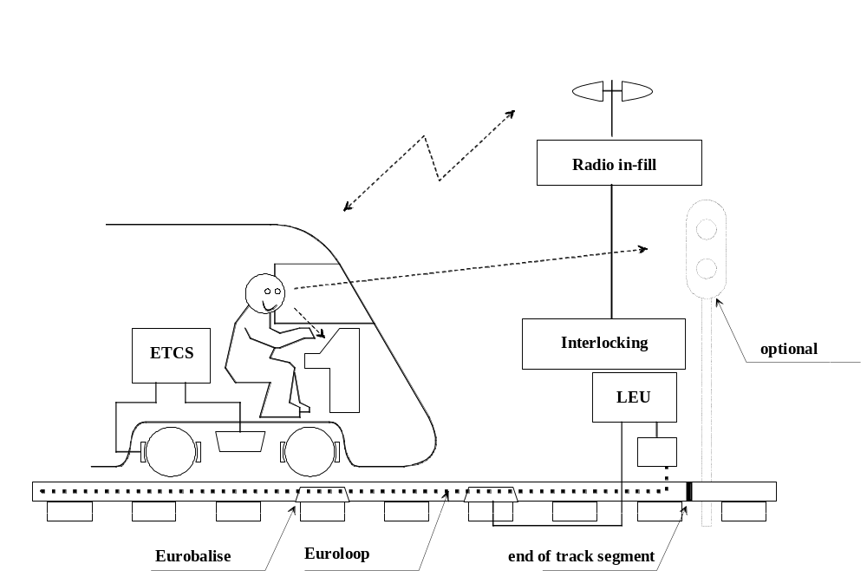
Figure 5: ERTMS/ETCS Application Level 1 with infill function by Euroloop or Radio in-fill

Summary of characteristics of Application Level 1

Trackside equipment:
- Eurobalises for spot transmission from track to train.
- Eurobalises must be able to transmit variable information.
- Semi continuous infill transmission by using Euroloop or radio in-fill is optional.

Main ERTMS/ETCS trackside function:
- Determine movement authorities according to the underlying signalling system.
- Transmit movement authorities and track description data to the train.

On-board equipment:
- Onboard equipment with Eurobalise transmission.
- Euroloop transmission if infill by Euroloop is required.
- Radio in-fill transmission if infill by radio is required.

Main ERTMS/ETCS on-board function:
- Reception of movement authority and track description related to the transmitting balise.
- Selection of the most restrictive value of the different speeds permitted at each location ahead.
- Calculation of a dynamic speed profile taking into account the train running/braking characteristics which are known on-board and the track description data.
- Comparison of the actual train speed with the permitted speed and commanding of the brake application if necessary.
- Cab signalling to the driver.

ERTMS/ETCS Application Level 2

General description

ERTMS/ETCS Level 2 is a radio based train control system which is used as an overlay on an underlying signalling system.

Movement authorities are generated trackside and are transmitted to the train via Euroradio.

ERTMS/ETCS Level 2 provides a continuous speed supervision system, which also protects against overrun of the authority.

Train detection and train integrity supervision are performed by the trackside equipment of the underlying signalling system (interlocking, track circuits etc.) and are outside the scope of ERTMS/ETCS.

Level 2 is based on Euroradio for track to train communication and on Eurobalises as spot transmission devices mainly for location referencing.

The trackside radio block centre which provides the information to the trains knows each ERTMS/ETCS controlled train individually by the ERTMS/ETCS identity of its leading ERTMS/ETCS on-board equipment.

Note: Lineside signals can be suppressed in Level 2.
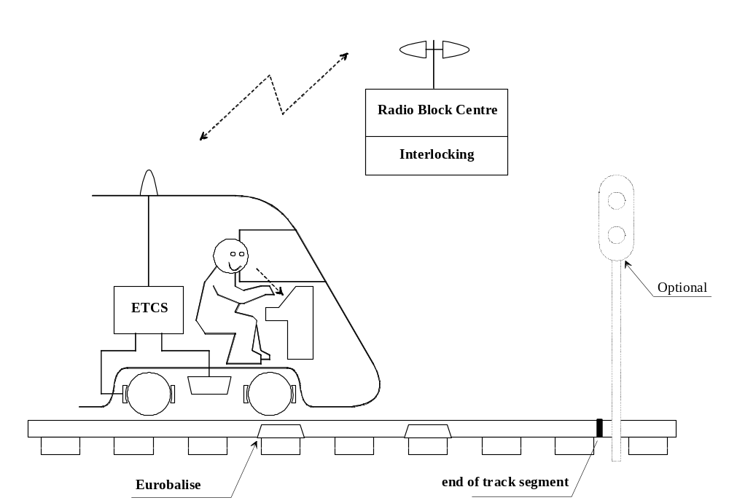
Figure 6: ERTMS/ETCS Application Level 2

Summary of characteristics of Application Level 2

Trackside equipment:
- Radio block centre.
- Euroradio for bi-directional track-train communication.
- Eurobalises mainly for location referencing.

Main ERTMS/ETCS trackside function:
- Knowing each train equipped with and running under ERTMS/ETCS within an RBC area by its ERTMS/ETCS identity.
- Following each ERTMS/ETCS controlled train’s location within an RBC area.
- Determine movement authorities according to the underlying signalling system for each train individually.
- Transmit movement authorities and track description to each train individually.
- Handing over of train control between different RBC’s at the RBC-RBC borders.

On-board equipment:
- Onboard equipment with Eurobalise and Euroradio transmissions.

Main ERTMS/ETCS on-board function:
- The train reads Eurobalises and sends its position relative to the detected balises to the radio block centre.
- The train receives a movement authority and the track description via Euroradio relating to a balise.
- Selection of the most restrictive value of the different speeds permitted at each location ahead.
- Calculation of a dynamic speed profile taking into account the train running/braking characteristics which are known on-board and the track description data.
- Comparison of the actual train speed with the permitted speed and commanding of the brake application if necessary.
- Cab signalling to the driver.

ERTMS/ETCS Application Level 3

General description

ERTMS/ETCS Level 3 is a radio based train control system.

Movement authorities are generated trackside and are transmitted to the train via Euroradio.

ERTMS/ETCS Level 3 provides a continuous speed supervision system, which also protects against overrun of the authority.

Train location and train integrity supervision are performed by the trackside radio block centre in co-operation with the train (which sends position reports and train integrity information).

Level 3 is based on Euroradio for track to train communication and on Eurobalises as spot transmission devices mainly for location referencing.

The trackside radio block centre which provides the information to the trains knows each train individually by the ERTMS/ETCS identity of its leading ERTMS/ETCS on-board equipment.

Note: Lineside signals are not foreseen to be used when operating in Level 3.
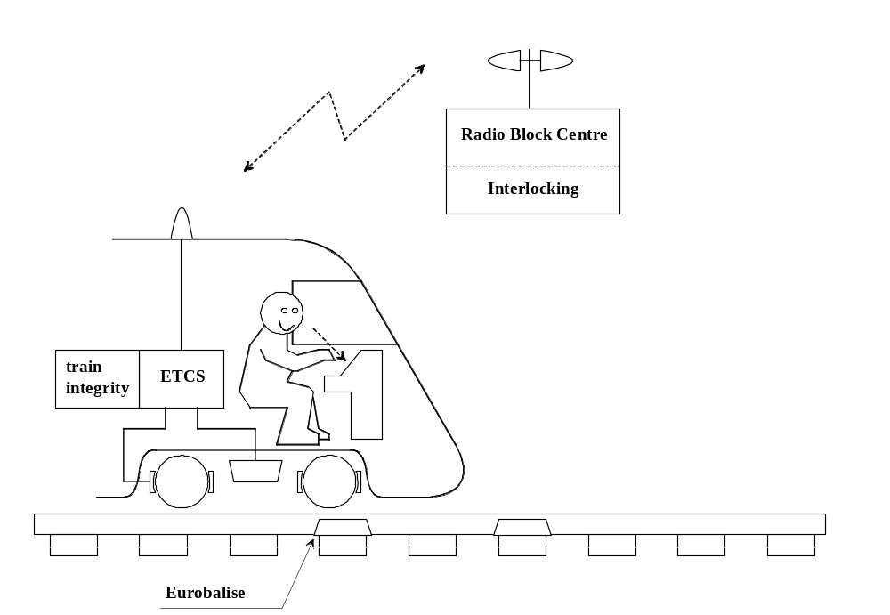
Figure 7: ERTMS/ETCS Application Level 3

Summary of characteristics of Application Level 3

Trackside equipment:
- Radio block centre.
- Euroradio for bi-directional track-train communication.
- Eurobalises for mainly location referencing.

Main ERTMS/ETCS trackside function:
- Knowing each train within an RBC area by its ERTMS/ETCS identity.
- Following each trains location within an RBC area.
- Route locking and route releasing based on information received from the trains.
- Determine movement authorities for each train individually.
- Transmit movement authorities and track description to each train individually.
- Handing over of train control between different RBC’s at the RBC-RBC borders.

On-board equipment:
- Onboard equipment with Eurobalise and Euroradio transmissions.
- Train integrity proving system.

Main ERTMS/ETCS on-board functions:
- The train reads Eurobalises and sends its position relative to the detected balises to the radio block centre.
- The train monitors train integrity (external function, not part of ERTMS/ETCS) and sends this information to the radio block centre.
- The train receives a movement authority and the track description via Euroradio relating to a balise.
- Selection of the most restrictive value of the different speeds permitted at each location ahead.
- Calculation of a dynamic speed profile, taking into account the train running/braking characteristics which are known on-board and the track description data.
- Comparison of the actual train speed with the permitted speed and commanding of the brake application if necessary.
- Cab signalling to the driver.

Level transitions

An ERTMS/ETCS equipment which is not isolated always operates in one of the above described levels. All transitions between these levels are performed according to defined functions and procedures.

Additional national functions and rules which might be used by an individual railway to for example prevent not equipped trains from entering a level 2/3 area are not specified here and have to be implemented outside ERTMS/ETCS.

The following table shows all possible transitions (marked with Grey):
to  from | 0 | STM | 1 | 2 | 3
0
STM |  | a)
1
2 |  |  |  | b)
3 |  |  |  |  | b)
Table 1: Possible level transitions.
- Transitions between level STM and level STM describe the switching from one STM to another STM.
- Transitions between level 2 and level 2 respectively between level 3 and level 3 describe the handover between RBC’s.

